

Milestone Assessment -2

Solution document

Document Version / Details: Ver. 2.1/ 02-Jan-2023

Yadeshwaran H S

Requiremts : CI/CD pipeline System

• Git - local version control system.

• GitHub - As Distributed version control system.

• Jenkins - Continous Integration tool.

• Maven - As a Build Tool.

• Anisible - Configuration Management & Deployment tool.

• docker -Containerization

• Kubernetes - As Container Management Tool.

**Build and Deploy on Developer Server.**

Setup CI/CD with GitHub,Jenkins,Maven&Tomcat

• Setup Jenkins

• Setup & Configure Maven , Git.

• Setup Tomcat Server.

• Integrating GitHub,Maven ,Tomcat Server with Jenkins

• Create a CI and CD Job.

• Test the Deployment.

**Setup Developer Server**

• Setup a Linux EC2 instance

• Install Java

• Install Git

• Push java code

• Acces code in github

**🡪 Setup a Developer-server EC2 instance**

* **Generate SSH key to connect with git**

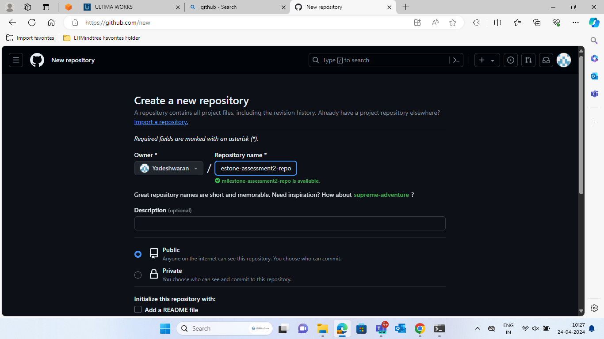

**🡪 Create a repository in github.**

* **Add the sshkey in github to provide authentication.**

* **Commands to push the code into the github**

* **The java file gets commited into the github.**

**Build and Deploy on Tomcat Server.**

Setup CI/CD with GitHub, Jenkins, Maven & Tomcat.

• Setup Jenkins

• Setup & Configure Maven , Git

.

• Setup Tomcat Server

.

• Integrating GitHub,Maven ,Tomcat Server with Jenkins

• Create a CI and CD Job.

• Test the Deployment.

**Setup Jenkins Server**

• Setup a Linux EC2 instance

• Install Java

• Install Jenkins

• Start Jenkins

• Access Web UI on port 8080

* **Instance to create a jenkins-server.**

* **Install jenkins and start the jenkins.**

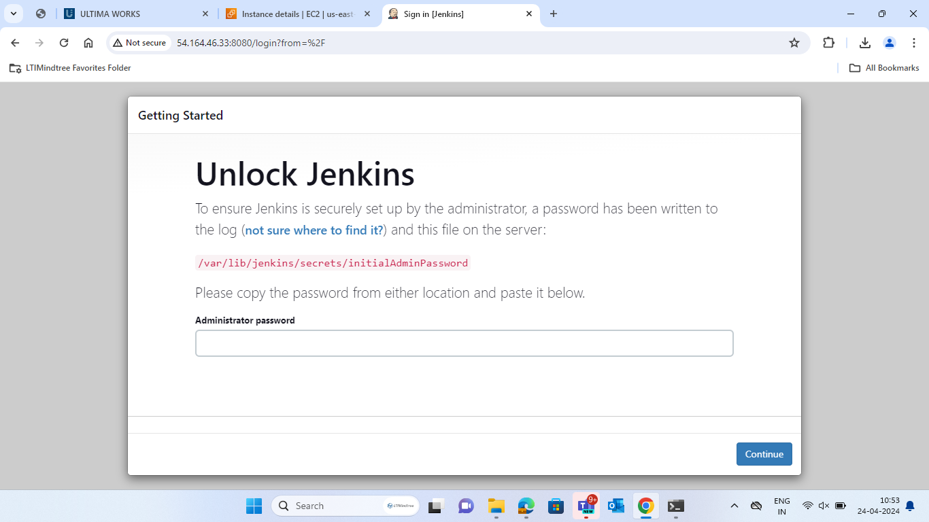

* **Access Web UI on port 8080**

* **Create the admin and setup password for the adminuser**

* **Add webhook to provide integration from github and jenkins**

* **Webhook has been added succesfully.**

* **Run First Jenkins Job**

**Integrate Tomcat in CI/CD pipeline:**

• Setup Tomcat Server

• Setup a Linux EC2 Instance

• Install Java

* **Download Tomcat server in developer server.**
* **A screenshot of a computer screen

  Description automatically generated**
* **Installed tomcat server.**

• Configure Tomcat

• Start Tomcat Server

• Access Web UI on port 8080

* **Host tomcat server in the web.**

**Tomcat server has been depolyed in the web and the web-app which has been deployed in the developer server has been deployed here.**

**Prepare Ansible Server:**

**• Setup EC2 Instance**

**• Setup hostname**

**• Create ansadmin users**

**• Add Users to sudoers file**

**• Generate ssh keys**

**• Enable Password Based Login**

**• Install Ansible**

* **Create ansible server instance.**

**Configure ansible and jenkins**

* **Jenkins and ansible server has been connected successfully**

**Now create a new item in jenkins for ansible job**

**EKS installation procedure**

**Kubernetes Setup using eksctl**

**Pre-requisites:**

**• an EC2 Instance**

**• Install AWSCLI latest version**

**🡪Setup kubectl**

**🡪Create an IAM Role and attach it to EC2 instance**

**🡪 Note:**

create IAM user with programmatic access if your bootstrap system is outside of AWS IAM user should have access to

IAM

EC2

CloudFormation

🡪Create your cluster and nodes

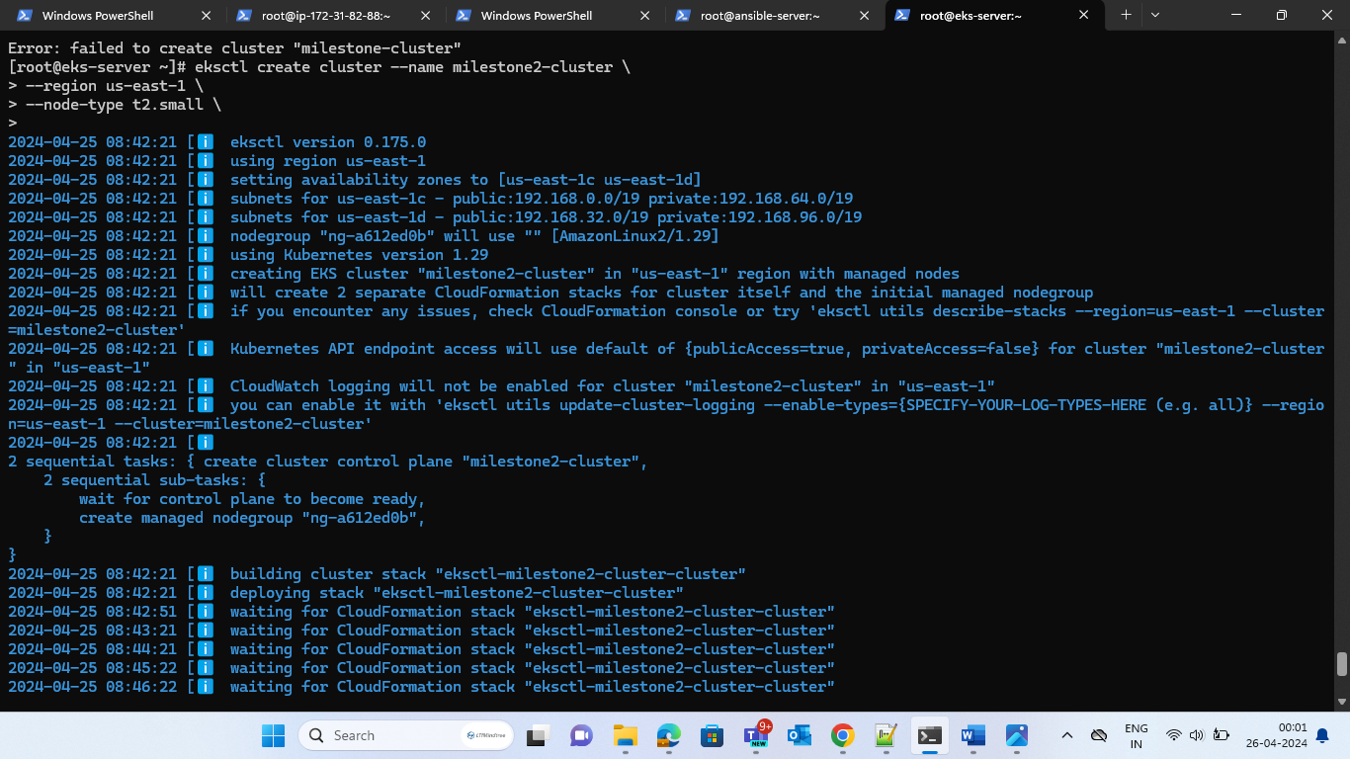

**Creating playbook:**

• On Ansible Node

• Add to host file

• Copy ssh keys

• Test the Connection

**ad84523ddd709444f975b234daef362e-1856731511.us-east-1.elb.amazonaws.com**

* **Expose this command link to the browser and youll get the desired output.**

